SUMMER PROJECT’ 25

Solving Inventory Inefficiencies Using SQL

This project aims to build a comprehensive inventory monitoring, forecasting, and optimization system using structured sales and inventory data. It incorporates internal product movement, store geography, promotional events, and external factors like weather and seasonality.

Using SQL analytics, I have engineered tables, analysed trends, identified patterns, and created actionable KPIs that guide operations and strategic decisions across procurement, demand planning, and supply chain stability.

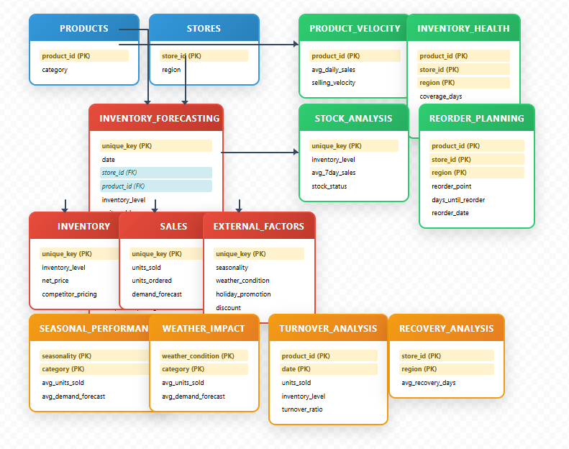

I have created many tables and relational schemas to ease out the data. From main table to decentralizing data into easier tables. Also Cleaned Data to remove outliers and random rows with wrong info.

ANALYTICS AND LOGICS

1. **Selling Velocity Classification**

* Calculated average daily units sold per product
* Used quartile segmentation:
  + Top 25%: Fast Selling
  + Bottom 25%: Slow Selling
  + Middle: Medium Velocity

1. **Inventory Level Status Analysis**

* Compared inventory against demand forecast

1. **Stock Adequacy (Overstocking & Understocking)**

* 7-day rolling average of units_sold used as baseline

1. **Seasonality and External Conditions**

* Aggregated and grouped sales by:
  + Season (Winter, Summer, etc.)
  + Weather (Rainy, Sunny, Snowy)
  + Promotional periods

1. **Inventory Lag & Recovery Days**

* Computed lag between expected and actual inventory
* Calculated recovery days:
  + Lag / 7-day moving average of sales or orders

1. **Inventory Health Assessment**

* Defined:
  + Coverage Days = Current Inventory / Average Sales
  + Recovery Days = Time to restore normal inventory

1. **Reorder Point & Date Estimation**

* Moving average of sales used for forecasting

1. **Demand Forecast Adjustment**

* Forecast recalibrated using seasonal-weather multipliers

KEY INSIGHTS

1. Selling velocity summary

* Helps to classify as fast selling and slow selling Product
* Each store has Clothing and Electronics as highest sellers

1. Stock Status

* Depicts Understocked and overstocked products
* Mainly North and South region stores have issue of understocking

1. Inventory Status

* Depicts low and high inventory across stores
* Mainly north and south region stores are not maintained properly and have low inventory

1. Inventory Lag

* Few products have very common inventory lag showing need to change supplier
* Mainly products have reasonable lag that is easily covered

1. Recovery Period Analysis

* Mainly S002 has higher recovery period for inventory as compared to others
* S005 has fastest recovery among all

1. Inventory Health

* This mainly shows overstocking of product up to concern able levels to prevent cost of over storage
* Some products like P0079 , P0083 , P0116 , P0067 etc. are slow movers and hence mostly overstocked

1. Reorder Estimation

* Highest reorder time is 2.25 days due to high stock while lowest is -0.625 due to low stock
* Except for a few products mostly have reorder period within recovery period which dhows smooth functioning

1. Adjusted Demand Forecast

* The demand forecast changed on basis of time series models is approx. same as before with error almost 2-3% only

1. Inventory Turnover

* Many products perform evergreen with inventory turnover greater than 0.6 throughout the year

1. External Impacts

* Seasonal Impact: - Clothing have exceptional higher sales in winters while Groceries in summer while rest remains almost equal throughout the year
* Weather Impact: - Electronics Sales drop during rainy season while rest all almost remain same throughout the year